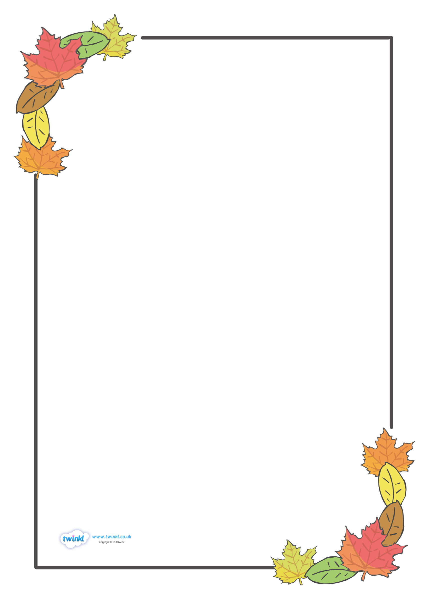

**Monday 15th September 2025**

Our first full week in school, how exciting!

The children did so well last week but they will get very tired towards the end

of the week. Be prepared for some very tired and grumpy children when they

come out of school. Allow them some time and space to relax after school and

don’t ask too many questions about their day. They will tell you things when they

are ready and remember to check the website for photos of some of our

learning.

**School Dinner Menu W/C - 15/09**

|  |  |  |  |  |
| --- | --- | --- | --- | --- |
| **Monday** | **Tuesday** | **Wednesday** | **Thursday** | **Friday** |
| Pasta Bolognaise  Cheesy Swirl  Jacket Potato | Caribbean Chicken Curry  Tomato Pasta  Jacket Potato | Roast Gammon  Samosa Puff  Jacket Potato | Mac Cheese  Spinach Biryani  Jacket Potato | Chicken Bites  Cauliflower Nuggets  Jacket Potato |

**Mathematics**

This week we are looking at matching objects in our whole class work and then in small groups. Matching is a simple form of sorting and is the beginning of logical thinking. Through matching, children learn one-to-one correspondence and this supports them in their counting skills.

**Phonics**

This week we will introduce our first phoneme /s/. We will explore listening to the phoneme at the beginning of words and recognise the graphemes ‘s’. We will also begin to practice writing the letter in the correct letter formation. Please reinforce our learning at home using the booklet sent home on Friday, if your child is interested, or by highlighting the phoneme in everyday situations.

**Outdoor learning and Playtimes**

Please help your child to learn how to take off and put on their jumpers and shoes as this means they can independently access all parts of the classroom and

get straight outside at playtimes.

**Topic Work – Our Families**

Thank you to all those who have already sent into school this week a photograph of their family to share with the class. The children will enjoy sharing their photos with the class and then they will go on our classroom display. If you have not sent a photo in yet, please do so this week. You can always email me your photo

if easier.



**School Rules**

This week we will be introducing and discussing our school rules to the children.

* Ready
* Respectful
* Safe

Please ask your children later on this week about our rules and can they remember what they mean?

**Harvest Assembly**

We are looking forward to performing a song at our whole school Harvest Assembly on Wednesday 1st October at 09:00. Parents are welcome to join us for the assembly. We are not staying for the whole assembly as it will be too long for the children to sit through.

Thank you for your continued support.