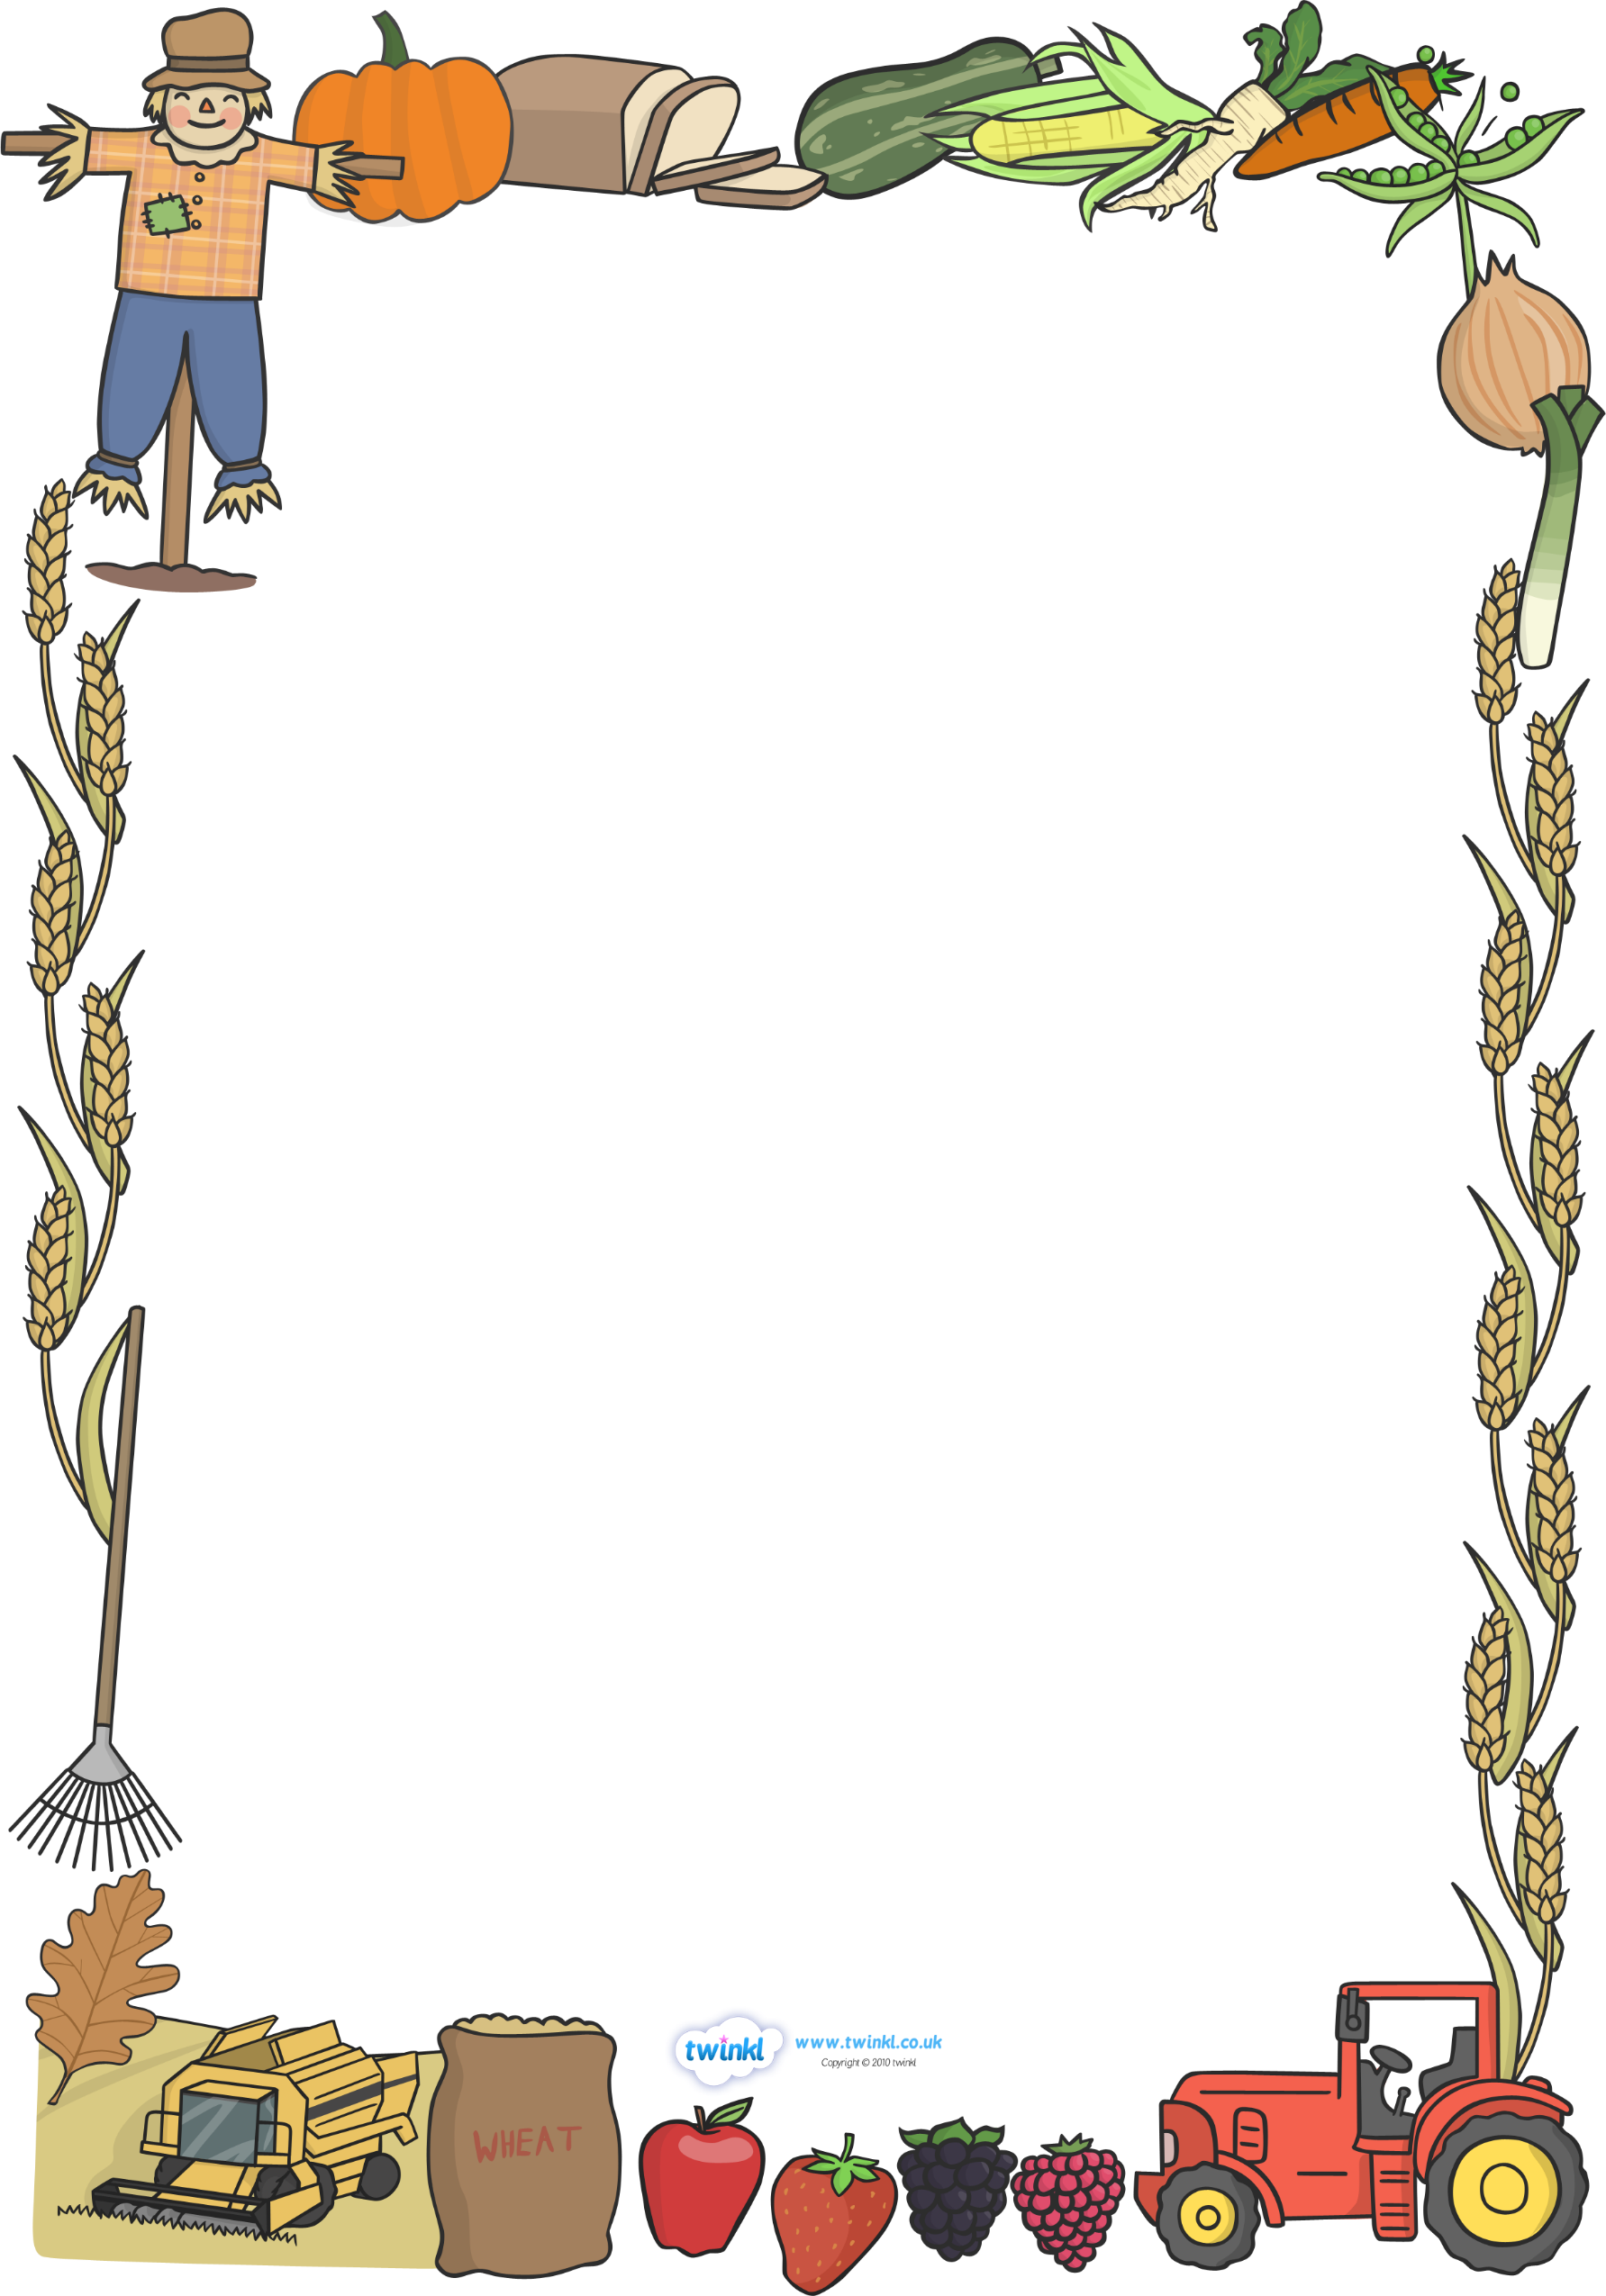

**Monday 29th September 2025**

**School Dinner Menu W/C - 29/09**

|  |  |  |  |  |
| --- | --- | --- | --- | --- |
| **Monday** | **Tuesday** | **Wednesday** | **Thursday** | **Friday** |
| Veg Katsu Nuggets  Onion Bhaji  Jacket Potato | Beef & Onion Pie  Cheesy Pasta  Jacket Potato | Roast Chicken  Vegetable Hotpot  Jacket Potato | BBQ Pork  Tomato Spaghetti  Jacket Potato | Margherita Pizza  Tuna Pasta  Jacket Potato |

**Phonics**

This week we will introduce the phoneme /t/. We will explore listening to the phoneme at the beginning of words and recognise the graphemes ‘s’,’a’ and ‘t’. We will also begin to practice writing the letter in the correct cursive formation. Please reinforce our learning at home using the booklet sent home on Friday, if your child is interested, or by highlighting the phoneme in everyday situations.

**Mathematics**

In maths this week we will be looking at measurement and comparing size, capacity and mass. We will be introducing new vocabulary to allow children to compare, order, and find differences and similarities within these areas of measurement.

**Harvest Assembly**

This week we will be practicing our song and preparing the children to perform in the hall at our whole school Harvest Assembly on Wednesday 1st October at 09:00. Please do come along if you can.

**Coats**

As the weather gets more changeable please ensure that your child has a coat in school every day and please make sure it is clearly named. Please also help your child to learn how to put their coat on independently and begin to learn how to zip it up. This means they can independently access all parts of the classroom and get straight outside at playtimes.

**Reading and Phonics meeting**

We will hold a meeting for parents on Thursday 16th October at 14:30 to discuss the teaching of reading and Phonics in EYFS and how you can support your child at home. We will hold this on the same day as our Parents Evening to help working parents. Please do come along if you can and the slides from the meeting will then be put on our class page on the website.



**Dates for next week**

Monday 6th October – School individual and sibling photgraphs

YR will have our photos taken first so we still look neat and tidy.

Wednesday 8th and Thursday 9th October – Lifebus visit to school. We will be participating in an interactive learning session ‘Being Me’.

Tuesday 14th October and Thursday 16th October Parents Evening

Thursday 16th October EYFS Reading Meeting

Thank you for your continued support.