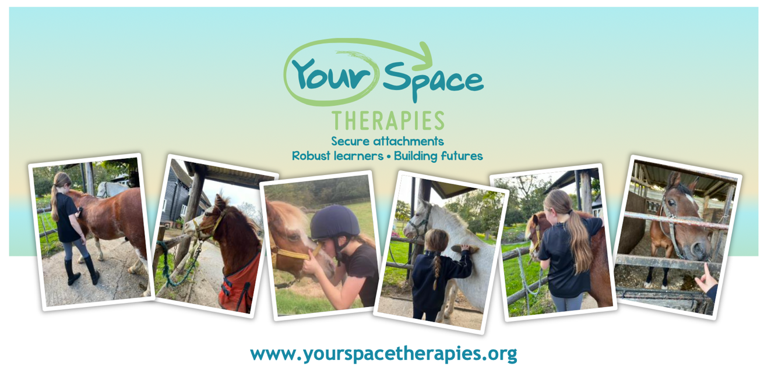
🌼 Easter Holiday Mindfulness Pony Day for Kids! 🌼

Dates: Thursday 2nd April and Friday 10th April
Time: 9.30am- 2pm
Location: Hill Crest Farm, Horsham
Join us for a magical day of ponies, riding, art, friendship, and mindfulness!
✨ What to Expect:
💖 Mindfulness Time with Ponies
🦄 Pony Care
🏇 Riding and Mounted Games
🌳 Connect with Arts and Nature
🎉 Make New Friends
Click the link to book the day of your choice:
Thursday 2nd April- Mindfulness Pony Day- Book Now!
Friday 10th April- Mindfulness Pony Day- Book Now!

Cost: £140 per child
BY PURCHASING A TICKET VIA EVENTBRITE, YOU ARE PAYING £40 DEPOSIT. YOU WILL BE INVOICED VIA EMAIL FOR THE OUTSTANDING AMOUNT ON 27th MARCH.
Spaces limited to 10 children per day

We are an inclusive team and warmly welcome children with Special Educational Needs and Disabilities (SEND). We celebrate diversity and are committed to providing a supportive environment where every child can thrive.

