**Mathematics**

Written October 2023

**Intent** - What are our curriculum aims?

At Stocks Green Primary School, **our mathematics curriculum is designed to meet our curriculum aims** which are to:

* recognise children’s prior learning
* provide first hand learning experiences
* promote creativity
* make connections between subjects and real life
* promote safe, equal, caring and enjoyable relationships and discussing real-life situations appropriate to the age and stage of pupils.
* encourage the children to develop interpersonal skills
* build resilience and become creative, critical thinkers
* understand their own strengths and areas for development and know how to face challenges
* promote responsibility for learning and future success

Further to this, we have specific aims for pupils leaving our school having experienced our mathematics curriculum. We intend for all pupils to develop a deep, secure and adaptable understanding of mathematics that equips them for their future learning and life in a numerate world. We follow the **White Rose Maths scheme of learning**, which provides a clear, progressive structure that supports children in building a strong foundation in mathematical concepts. Our curriculum ensures that every child leaves our school confident and competent in their mathematical understanding, with the ability to reason, solve problems and apply their knowledge in a wide range of contexts.

Our mathematics curriculum is built upon the fundamental principles and concepts of number, calculation, geometry, measurement and statistics. We ensure that pupils understand and can apply the core strands of mathematical learning: **fluency**, **reasoning** and **problem-solving**, using a consistent **Concrete–Pictorial–Abstract (CPA)** approach. This enables children to build conceptual understanding alongside efficient and accurate procedures.

We intend for pupils to analyse and approach problems in mathematical terms, selecting appropriate strategies and tools to support their reasoning. Pupils experience a wide variety of representations and methods throughout their time at school, including both mental and written approaches, helping them to develop a toolkit of strategies that are transferable to different contexts.

As a school, we recognise our responsibility to prepare pupils for a world in which mathematical understanding is critical—whether in financial literacy, data interpretation, design, science, or careers that may not yet exist. Therefore, our curriculum places strong emphasis on **building transferable skills**, logical thinking, and systematic approaches that extend beyond routine procedures.

The teaching of mathematics in our school is intended to **ignite curiosity** and promote a sense of enjoyment and achievement. We aim that in every maths lesson, children **know more and remember more** of the curriculum. The progression of **knowledge**, **skills** and **vocabulary** is carefully planned and sequenced to ensure that by the end of Year 6, pupils are ready for the next stage of their education with confidence and a strong mathematical foundation.

Finally, we are committed to developing pupils as **reflective, resilient and independent learners**, capable of justifying their thinking, learning from mistakes, and seeing themselves as mathematicians.

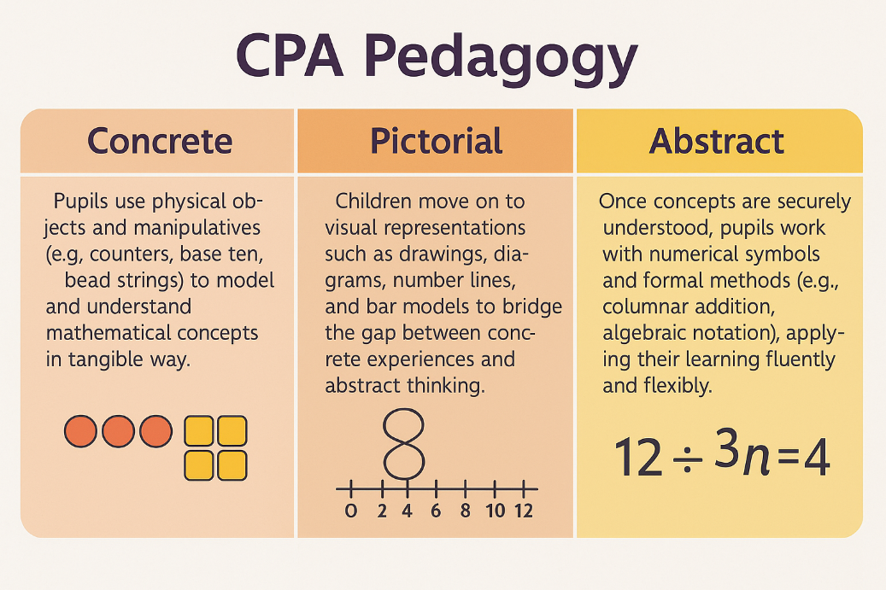The pedagogy of the White Rose Maths curriculum is fundamentally based on **three key stages**, commonly referred to as the **CPA approach**:

**Implementation** – How do we achieve our aims?

**Mapping concepts**

Within the domains of **Number**, **Calculation**, **Geometry**, **Measurement**, **Statistics**, and **Algebra**, we have identified key concepts such as place value, the four operations, fractions, spatial reasoning, and data handling. These are taught through the **Concrete–Pictorial–Abstract (CPA)** approach and sequenced using the **White Rose Maths scheme**. Concepts are mapped and revisited through progressive small steps, allowing children to build, retrieve and embed knowledge into their long-term memory over time.

For example, through the domain of ‘Number – Place Value’, children begin in EYFS by recognising numbers to 5 and understanding the concept of quantity. In Year 1, they develop an understanding of numbers to 100 and the place value of tens and ones. In Year 2, they build on this by working with numbers to 100 and beyond, including partitioning in different ways. In Year 3, children deepen their understanding by recognising the place value of each digit in three-digit numbers. In Year 4, they extend this to four-digit numbers, rounding numbers to the nearest 10, 100 and 1,000. In Year 5, pupils explore numbers to at least 1,000,000, interpreting and comparing large numbers. By Year 6, children confidently work with numbers up to 10,000,000, including comparing, ordering, and rounding, fully prepared to apply their understanding across the wider mathematics curriculum.

**Progression and sequencing**

The **mathematics curriculum** has been designed to provide children with the **knowledge**, **skills**, and **understanding** required for **success** in secondary education and beyond. Each **domain** has been carefully **sequenced** to build **systematically** over time, ensuring an **onward trajectory** towards future careers where **mathematical fluency**, **reasoning**, and **problem-solving** are essential.

For example, through the lens of **‘Number – Place Value’**, children are introduced to **recognising** and **understanding** small quantities in **EYFS**. This **foundational knowledge** is expanded **year on year**, culminating in **Year 6** where children confidently work with numbers up to **10 million**, ready to apply this knowledge in complex contexts such as **finance**, **data science**, and **engineering**.

Our **mathematics curriculum** is deliberately structured to be taught in a **particular order**, so that children build their mathematical knowledge **cumulatively** and **securely**. Lessons within each **domain** are written in **sequence**, ensuring that new concepts are only introduced once the necessary **prior knowledge** is **embedded**. Careful **progression** prevents **cognitive overload** and supports children in making **meaningful connections** across different areas of mathematics.

Our **carefully sequenced mathematics curriculum** ensures that pupils not only **acquire new knowledge and skills** at each stage but also **deepen their understanding over time**, preparing them for **future learning**, **wider application**, and **lifelong success**.

Mathematics lessons are designed to build conceptual understanding, fluency, reasoning, and problem-solving in a carefully sequenced and coherent way. Lessons follow the **White Rose Maths scheme** and are structured around small, progressive steps to ensure accessibility for all learners.

Each lesson typically includes:

* **Fluency practice** to secure and consolidate prior knowledge
* **Explicit teaching** of new concepts through the **Concrete–Pictorial–Abstract (CPA)** approach
* **Guided practice** using carefully chosen representations and scaffolds
* **Independent practice** to apply knowledge and deepen understanding
* **Opportunities for reasoning and problem-solving**, encouraging pupils to explain, justify, and apply their thinking

Teachers use **key vocabulary**, **sentence stems**, and **questioning** to develop mathematical talk and deepen reasoning. Misconceptions are anticipated and addressed through targeted questioning and feedback.

Curriculum delivery is **inclusive**, **ambitious**, and **adaptive**. Lessons are sequenced to ensure that children have the **prior knowledge** needed before moving on to more complex ideas. **Retrieval practice** and regular opportunities to revisit key concepts ensure that learning is transferred to long-term memory.

Through this consistent approach to lesson design and delivery, children are supported to **know more, remember more, and do more** in mathematics.

**Lesson design and curriculum delivery**

**Learning Journey Walls**

We believe that the effective use of **Learning Journey Walls** can act as the ‘silent teacher’ in the classroom. Effective Learning Journey Walls in mathematics visually map the progression of learning across a unit, providing clear prompts, key vocabulary, modelled strategies, representations, and steps towards mastery. They support pupils’ independence, reinforce prior learning, and guide them through current and future learning.

Learning Journey Walls are built up over the stages of curriculum delivery and should reflect the progression through small steps in a clear, accessible and supportive way. As such, the display should be **dynamic**—changing and growing as learning develops.

**Active ingredients of an effective Learning Journey Maths Wall:**

* The **key question** or **learning focus** displayed clearly
* **Key mathematical vocabulary** for the domain and topic
* **Modelled methods** or **worked examples** linked to the current learning
* **Concrete, pictorial, and abstract representations** appropriate to the concept being taught
* **Key sentence stems** or prompts for reasoning and explanation
* **Common misconceptions** addressed and corrected during the learning journey

The school aims for every child to achieve the learning intention for each mathematics lesson, framed through a clear learning objective or question. To achieve this, learning is carefully scaffolded to allow all pupils to access and achieve the intended outcome. The **White Rose Maths scheme** supports adaptive teaching by breaking concepts into small, manageable steps, enabling teachers to identify where scaffolding or additional challenge is required.

Scaffolding may take many forms depending on pupil needs, such as the use of **manipulatives**, **structured models and images**, **key vocabulary prompts**, **sentence stems for reasoning**, **part-part-whole models**, **worked examples**, **additional adult support**, or **targeted small group work**. Pupils are supported to access mathematical tasks as independently as possible, with learning pitched to be both **challenging and achievable**.

Through thoughtful adaptations, the school aims for a **high success rate** within each cohort, enabling strong progress for all pupils. Where a high success rate is not achieved, the **small steps approach** within the WRM framework allows teachers to revisit, consolidate, and re-teach specific concepts to ensure understanding before moving forward in the sequence.

**Adaptive Teaching**

We know how important it is to teach children the correct subject-specific vocabulary in mathematics. Rather than a one-off approach, we have embedded the consistent use and revisiting of mathematical vocabulary across each domain. For instance, children become familiar with key terms such as **partitioning**, **exchange**, **multiple**, **denominator**, and **perimeter**, using them confidently and accurately in different contexts. This structured vocabulary development helps pupils to explain their thinking, reason mathematically, and apply knowledge with precision. The progression of mathematical vocabulary is outlined within the progression of knowledge, skills, and concepts across the curriculum.

**Building vocabulary**

We believe that learning is most powerful when it has purpose, relevance, and ambition. In mathematics, we set high expectations for all pupils, ensuring that outcomes reflect secure understanding, fluency, and the ability to apply knowledge in a range of meaningful contexts. For example, when learning about measures, pupils apply their knowledge to real-world scenarios such as budgeting, project planning, and analysing data — building essential life skills for future education and employment.

Pupil outcomes are evidenced through **work in books**, **classroom discussion**, **practical application**, and **cross-curricular opportunities**. Learning is regularly captured through **assessment for learning**, **pupil voice**, **formative assessment activities**, and **retrieval practice**. Mathematics is further embedded across the curriculum to enhance pupils' confidence in using mathematics in diverse contexts such as science, geography, and design and technology.

We define progress in mathematics as pupils **‘knowing more, remembering more, and being able to do more’** over time. Progress is systematically monitored through retrieval tasks, fluency checks, and problem-solving activities. Teachers use assessment information to identify and address gaps swiftly, ensuring that all pupils, including disadvantaged and those with SEND, make strong progress from their individual starting points and are well-prepared for the next stage of education.

**Pupil Outcomes**



**Impact** – How will we know we’ve achieved our aims?

**Outcomes**

The impact of our mathematics curriculum can be seen through pupils' ability to confidently apply their mathematical knowledge and skills across a range of contexts. Pupils will demonstrate fluency in calculation, confidence in reasoning, and resilience in problem-solving. They will show the ability to use transferable mathematical strategies across different subjects and in real-world situations, preparing them for future education and life beyond primary school.

Staff assess pupils against the **progression of knowledge and skills** document at the end of sequences of learning, using an assessment by **exception approach. Assessment** is primarily formative, taking place within lessons to ensure that misconceptions are addressed swiftly and learning is secured. Over time, this builds a cumulative picture of each child's mathematical understanding and progress.

Assessment information is recorded on Arbor and analysed by the mathematics subject leader to **continually refine and enhance our curriculum**, ensuring it meets its stated intent and provides ambitious outcomes for all pupils.