Optional tasks Year 2 – Term 1
Task 1 Geography
Create a map or a poster of United Kingdom and show famous physical features of the UK, for example: Loch Lamond - in Scotland, Lake District or White Cliffs of Dover - England etc. Have you seen any of the features?
Tell us about them. You can attach postcards or photos in your project.
https://www.bbc.co.uk/bitesize/articles/zr8q7nb

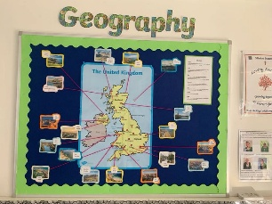

Task 2 - Science
Research and present: Life Cycle of an chosen animals
https://www.bbc.co.uk/bitesize/articles/zttckqt

Research using an encyclopaedia, science book or online platform and then present the life cycle of a frog or another animal of your choice.
You can draw, paint or create a 3D model showing each stage! You decide how to show the information.
Make sure each stage is labelled clearly. Have fun!

