Term 1
Make and Do: Paper Cup telephone
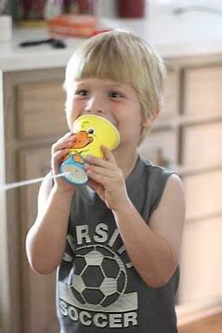
Curriculum Link: History (Term 1 Communication)

Using cups and string, make your own telephone and explore how you think it works!

Research and Present: Life Cycle of a Frog
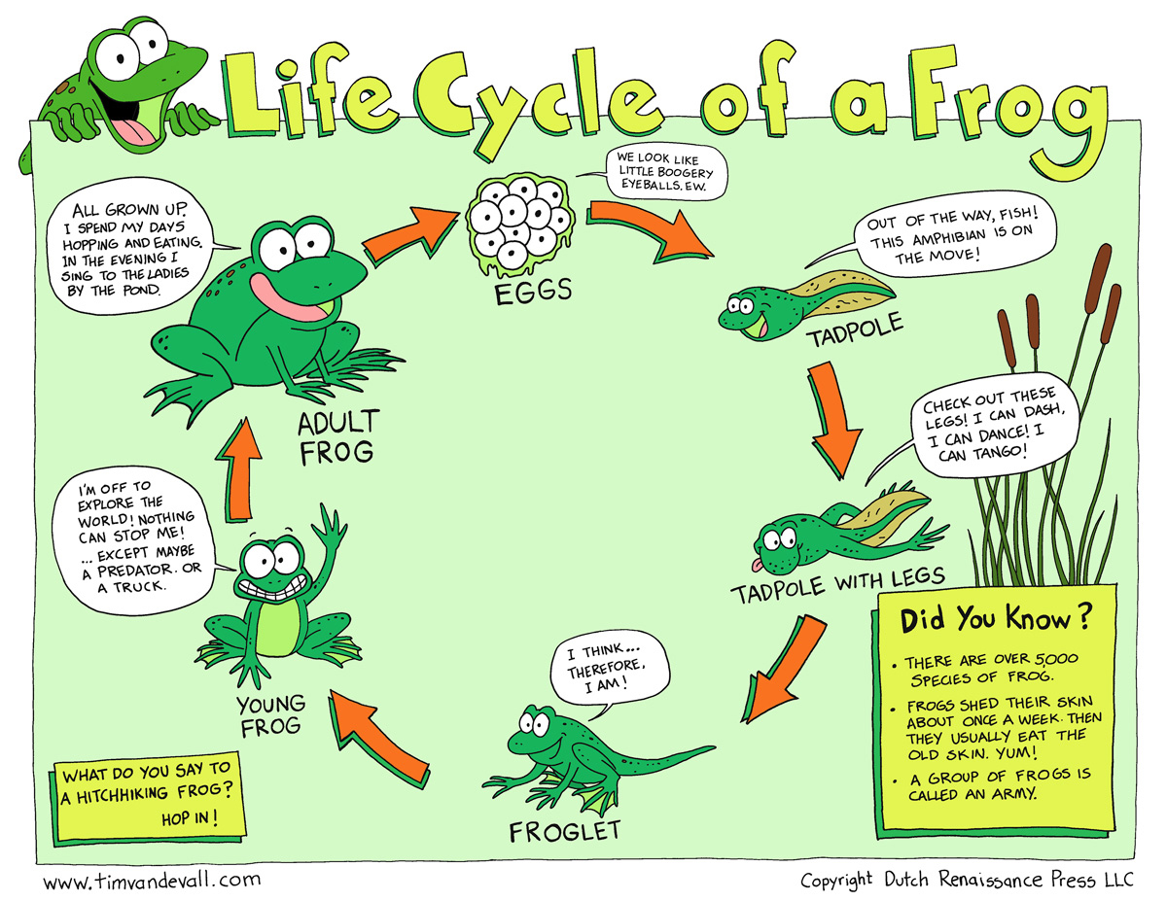
Curriculum Link: Science (Term 1 Animals including Humans: Animal Growth)

Research using an encyclopedia, science book or online platform and then present the life cycle of a frog.
You can draw, paint or create a 3D model showing each stage! You decide how to show the information.
Make sure each stage is labelled clearly. Have fun!

