

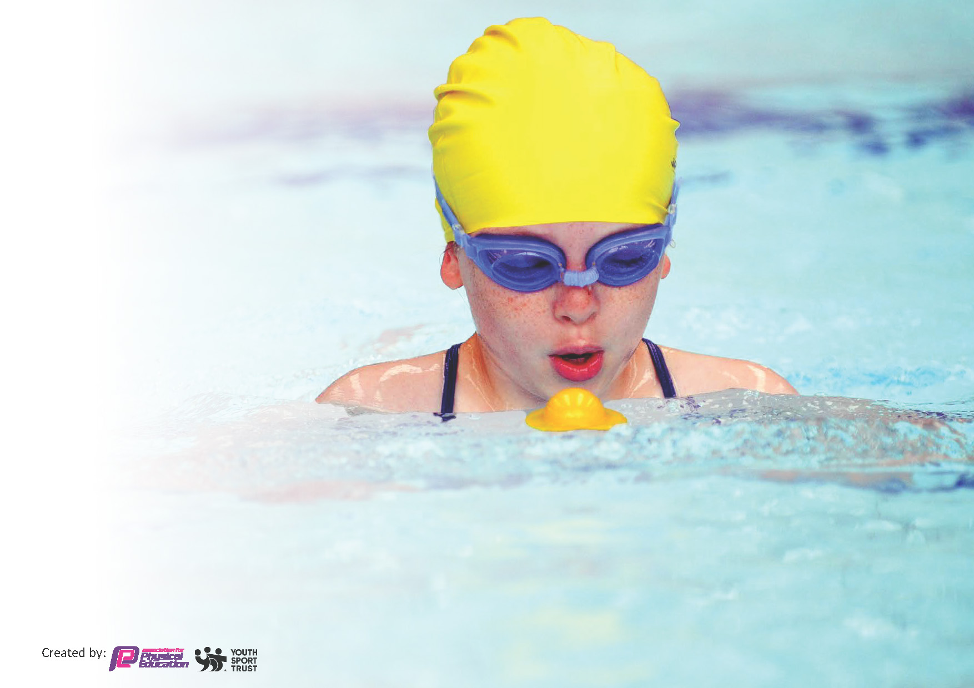
This template can be used for multiple purposes:
by:
- It enables schools to effectively plan their use of the Primary PE and sport premium
- It helps schools to meet the requirements (as set out in guidance) to publish information on their Primary PE and sport premium
- It will be an effective document to support Ofsted inspections enabling schools to evidence progress in Physical Education (PE) and evidence swimming attainment, which forms part of the PE National Curriculum. We would recommend schools consider
the Intent, Implementation and Impact of any spend, as examined within the Education Inspection Framework.

It is important that your grant is used effectively and based on school need.

Schools must use the funding to make additional and sustainable
improvements to the quality of the PE, School Sport and Physical Activity (PESSPA)
they offer. This means that you should use the Primary PE and sport premium to:

- Build capacity and capability within the school to ensure that improvements made now will benefit pupils joining the school in future years
- Develop or add to the PESSPA activities that your school already offers.

The Primary PE and sport premium should not be used to fund capital spend projects; the school’s core budget should fund these. Further detail on capital expenditure can be found in the updated Primary PE and sport premium guidance.

The Primary PE and sport premium guidance, outlines 5 key priorities that funding should be used towards. It is not

necessary that spending has to meet all the key priorities, you should select the priorities that you aim to use any funding towards.

Although completing this template is not a requirement for schools, schools are required to publish details of how they spend this funding. Schools must also outline what the impact this funding has had on pupils’ PE and sport participation and attainment and how any spending will be sustainable in the future. All funding must be spent by 31st July 2024.

The Department for Education has worked closely with the Association for Physical Education (afPE) and the Youth Sport Trust (YST) to develop this template and encourages schools to use it. This template is an effective way of meeting the reporting requirements of the Primary PE and sport premium.
Review of last year’s spend and key achievements (2022/2023)

We recommend you start by reflecting on the impact of current provision and reviewing your previous spend.

Activity/Action | Impact | Comments
- More clubs to engage a variety of children | - More children involved in clubs with the prospects of going to more competitions.  - Children showing more out of school achievements in assembly for sport. | - Positive comments for parents in regards to sports clubs  - Aiming more clubs for Years 3 and 4.
- Curriculum not hitting all the targets we wanted it to throughout the year. Conversation at the end of the year with TWKSSP to update planning systems. | - New planning system was spoken about at the end of term 5 2023 and showed real positives for what we could do moving forward. | - Carried over to 2023-24 to implement planning system
- Increase 30 minutes of physical exercise | - Researched more into daily mile and how we could incorporate it into our daily routine. Hopefully to continue this into next academic year. | - Carried over to 2023-24 to see how we can update and review the structure of the daily mile and active breaks.
- Encourage competition | - More children wanting to be involved in competition and clubs  - More children the attending clubs in school as they hope to attend an event | - Carried over to 2023-24 to continue this.  - Need to find events that coordinate with Years 1 and 2.

Key priorities and Planning
This planning template will allow schools to accurately plan their spending.

Action – what are you planning to do | Who does this action impact? | Key indicator to meet | Impacts and how sustainability will be achieved? | Cost linked to the action
Develop the Opal Provision, ensure maximize the opportunity got physical movement for all | Senior Leaders / Play leaders – as they support the running of Opal  Pupils– as they will take part | Key indicator 2 -The engagement of all pupils in regular physical activity – the Chief Medical Officer guidelines recommend that all children and young people aged 5 to 18 engage in at least 60 minutes of physical activity per day, of which 30 minutes should be in school.  Key indicator 4: Broader experience of a range of sports and activities offered to all pupils.  Key indicator 3: The profile of PE and sport is raised across the school as a tool for whole school improvement. | More pupils meeting their daily physical activity goal, more pupils encouraged to take part in active breaks.  Opal Picnic ran with parents in attendance to encourage active play.  Less recorded incidences of poor behavior at lunchtime and break times reduced. | - £78.92 for equipment to support the running of Opal  - £129.84 for Opal
Review extracurricular clubs to create data for participation and to create more participation in competitive events alongside this.  Re – establish and create new strong links with other local clubs through assemblies and workshops. | PE Leaders / SLT – as they organise clubs  Netball Coaches- as they will be running the clubs weekly and taking the students to competitions outside of school  Pupils– as they will take part  GN- as she will be running Dance and Cheerleading clubs and taking students to competitions and shows outside of school | Key indicator 2 -The engagement of all pupils in regular physical activity – the Chief Medical Officer guidelines recommend that all children and young people aged 5 to 18 engage in at least 60 minutes of physical activity per day, of which 30 minutes should be in school.  Key indicator 4: Broader experience of a range of sports and activities offered to all pupils.  Key indicator 5: increased participation in competitive sport. | More pupils meeting their daily physical activity goal, more pupils encouraged to take part in active breaks.  10 Sporting clubs run across the year.  Increased participation for clubs, increasingly when linked to an event to show what they have learnt.  Increased participation in clubs through assemblies shows cases. Leigh Academy Cheerleading Competition, Stag Theatre Dance Show | - Cheerleading and Dance Hoodies which were worn by the team at events and during lessons. £64.00 &  £203  - Cheerleading Leotards for competition held at Leigh Academy and a Dance Show £177.18  - Running Medals to hand out after children have ran their marathon over the terms £43.79  - Trophies £55.83  - Netball Coaching for top up payments for parents  Coach 1: £787.50  Coach 2: £400  Extra payments: £73.10  - Props and costumes for the Dance competition at the Stag Theatre: £110.32  - Gymnastic Clubs run through Terms 1-6 for all year groups by Trinity:  Term 1&2: £101.00  Term 3&4: £129.50  Term 5&6: £118.00  - Trinity Dance Workshops run to encourage children to attend clubs outside of school. Assembly to the whole school introducing clubs run through company: £120.00
Further, develop the cultural capital provision for all pupils to ensure we provide varied and high level opportunities and experiences. | SLT/ PE Leaders as they take a key role in ensuring all children are provided with high-level opportunities. | Key indicator 4: Broader experience of a range of sports and activities offered to all pupils.  Key indicator 3: The profile of PE and sport is raised across the school as a tool for whole school improvement. | Cultural capital opportunities offered to pupils in the school.  - Local football and Netball matches across schools  - Cheerleading competition  - Dance show held at the Stag Theatre for Dance and Cheerleading group  - Hildenborough Road Races taken part by some children in the school.  - Year 6 able to access a weeks’ worth of opportunities at their residential trip.  - Take Price Bike ability for Year 6 students to ensure safety whilst cycling on the road. | - Dance competition entry run at the Stag Theatre attended by both our Cheerleading and Dance teams : £125 for entry.  - School Journey payment : £2,750.00  - Hildenborough Road Race entry to ensure the event would be able to take place and support the running of the event: £100  - Kent LTA entry fee: £10  - Bike ability course: £150
Implement our revised PE curriculum and overview to include more sports.  Ensure teachers are confident in teaching the new curriculum.  Ensure the curriculum continues to be effective and ambitious for all pupils | SLT/ PE Leaders as they take a key role in ensuring all children are provided with high-level opportunities. They will also be implementing the new Pe curriculum and assessment planning.  Teachers: as they will be teaching the curriculum  Pupils as they will be involved | Key indicator 4: Broader experience of a range of sports and activities offered to all pupils.  Key indicator 3: The profile of PE and sport is raised across the school as a tool for whole school improvement.  Key indicator 2 -The engagement of all pupils in regular physical activity – the Chief Medical Officer guidelines recommend that all children and young people aged 5 to 18 engage in at least 60 minutes of physical activity per day, of which 30 minutes should be in school.  Key indicator 5: increased participation in competitive sport.  Key indicator 1: Increased confidence, knowledge and skills of all staff in teaching PE and sport. | Cultural capital opportunities offered to pupils in the school as the children have more opportunities to be involved in many sports that they may not have heard of before.  Curriculum is set out to include end of term intra houses between all year groups to support healthy competition.  CPD given over two terms for 4 teachers to support CPD.  Well received.  Update progression and skills document used to reflect learning over the year groups.  Equipment brought to support the introduction of the new curriculum and to update any resources that were outdated.  Sports leaders developed their skills during play leaders training that supported them when running lunchtime clubs. | - TWKSSP membership giving us access to members online events, CPD and planning systems: £4500  - Davies Sport  Hockey balls : £150.29  Balls/ Bean Bags/ Cones:£136.35  Javelin/ Golf balls: £158.35  Handball: £173.24  - KCS Order of multiple sports: £236.34  - Davies Sport order: £1957.34 for curriculum sport.
Ensure we are meeting the requirements set out by AfPE | PE Leaders take a key role in ensuring we meet the requirements | Key indicator 3: The profile of PE and sport is raised across the school as a tool for whole school improvement.  Key indicator 1: Increased confidence, knowledge and skills of all staff in teaching PE and sport. | Continuously able to reflect on the practices in around primary education.  Useful webinars in supporting leaders. | - AfPE subscription: £95
Ensure all children in Year 6 meet the requirements of swimming. | PE Leaders take a key role in ensuring we meet the requirements  Swim coaches who will assess the children during their sessions. | Key indicator 3: The profile of PE and sport is raised across the school as a tool for whole school improvement.  Key indicator 4: Broader experience of a range of sports and activities offered to all pupils. | Catch up sessions were run for children to ensure they met the requirements for swimming at the end of Year 6. Sessions were run on a smaller scale. | - Swimming Catch up payment to ensure all children met the requirements needed: £1953
Ensure the school field and playground is presented to support PE and Sport across the year. | PE Leaders take a key role in ensuring we have a safe environment  Caretaker to ensure risk assessments are correct. | Key indicator 3: The profile of PE and sport is raised across the school as a tool for whole school improvement. | One of the school playgrounds to be re-laid over the summer break due to general wear and tear that has occurred over the years.  Field maintained to support field games and to ensure safe environment for Sports Day and Intra Houses.  Markings replaced on playgrounds to support extracurricular clubs and curriculum learning. | - Boundary Landscaping used to maintain school field: £800  - Boundary lines for supporting on playground maintained to support teaching (Netball and Tennis lines): £1,000.00  - Line painter and paint used for Sports day: £359.11
Monitor and assess the implementation of the curriculum and take time to remain updated on new requirements. | PE Leaders take a key role in ensuring we monitor learning | Key indicator 1: Increased confidence, knowledge and skills of all staff in teaching PE and sport. | Time taken to plan and assess the new curriculum.  Lots of positive feedback in regards to planning.  Meetings with TWKSSP used to keep us updated with systems. | - Supply payments to cover classes whilst leaders met. £187.00  - Attendance of conference and supply to cover teachers for the day £427

Key achievements 2023-2024
This template will be completed at the end of the academic year and will showcase the key achievements schools have made with their Primary PE and sport premium spending.

Activity/Action | Impact | Comments
Ensure all children participate in a broad curriculum | New curriculum implemented and children now have the opportunity to learn a variety of sports. One of the lessons will link to the terms theme and the second lesson from Years 2-6, is a specific sport. | Implemented Term 2, continue to reflect throughout the year.
Ensure Opal provision has opportunities for physical movement for all. | - Swings, scooters, sports, football Rota  Equipment brought to encourage active break times. Parents attended an Opal lunch time, and were involved in play. Has been a great addition in the eyes of all stakeholders | Continued implementation into the new year
Daily Mile and Active breaks | - Now a key part in the routine of the day during transition for learning | Continued into next year

Swimming Data
Meeting National Curriculum requirements for swimming and water safety.
Priority should always be given to ensuring that pupils can perform safe self-rescue even if they do not fully meet the first two requirements of the National Curriculum programme of study

Question | Stats: | Further context  Relative to local challenges
What percentage of your current Year 6 cohort can swim competently, confidently and proficiently over a distance of at least 25 metres? | 93.55 % | Some children did not attend the swimming session catch-ups.
What percentage of your current Year 6 cohort can use a range of strokes effectively [for example, front crawl, backstroke, and breaststroke]? | 93.55 % | Some children did not attend the swimming session catch-ups.

What percentage of your current Year 6 cohort are able to perform safe self-rescue in different water-based situations? | 93.55% | Some children did not attend the swimming session catch-ups.
If your schools swimming data is below national expectation, you can choose to use the Primary PE and sport premium to provide additional top-up sessions for those pupils that did not meet National Curriculum  requirements after the completion of core lessons. Have you done this? | Yes | We used £1953.00 to ensure most of our Year 6’s were able to meet the requirements. Some children chose not to attend the sessions.
Have you provided CPD to improve the knowledge and confidence of staff to be able to teach swimming and water safety? | No | We hire in swimming coaches to support the teaching of swimming at a local pool.

Signed off by:

Head Teacher: | Peter Hipkiss
Subject Leader or the individual responsible for the Primary PE and sport premium: | Emily Smith (PE Lead)  Georgina Newton (PE Lead)
Governor: | (Name and Role)
Date: | 22/07/2024

